**Hotel Management System**

**DBMS LAB Mini Project**

|  |  |
| --- | --- |
| **NAME** | **SRN** |
| Akshay Girish Kaushik | PES1UG19EC027 |
| Navya Sree Paladi | PES1UG19EC192 |
| Netra Soraganvi | PES1UG19EC182 |

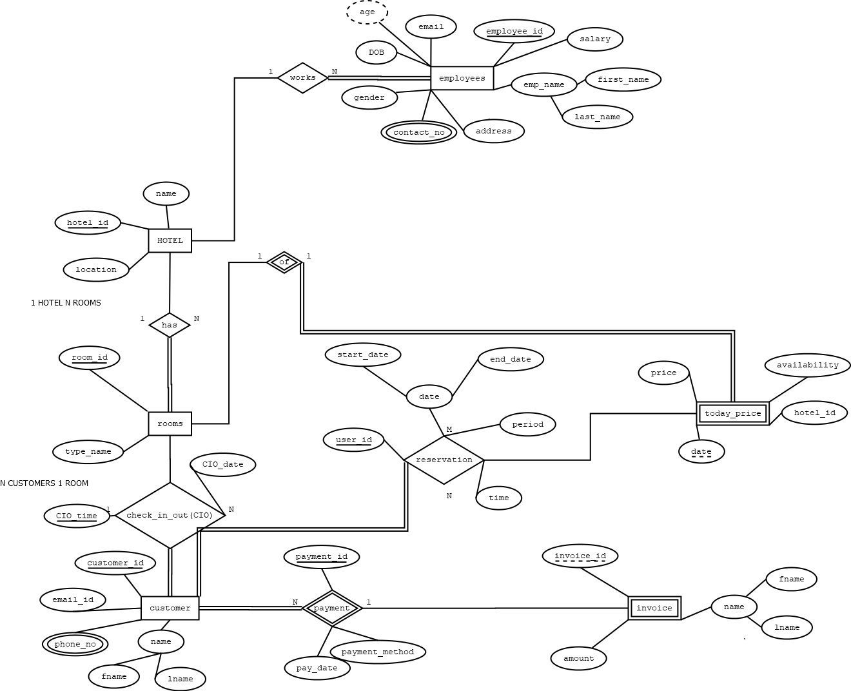**ER Diagram:**

**Schema:**

**SQL Commands to Create Table and the Output of Schema and Data:**

CREATE TABLE Hotel

(

name varchar(50) NOT NULL,

location varchar(50) NOT NULL,

hotel_id int primary key

);

CREATE TABLE Employee

(

employee_id int primary key,

email varchar(50) NOT NULL,

DOB date NOT NULL,

Fname varchar(20) NOT NULL,

LName varchar(20) NOT NULL,

address varchar(50) NOT NULL,

salary numeric(10,2),

gender char NOT NULL,

e_h_id int,

foreign key(e_h_id) references Hotel(hotel_id)

);

CREATE TABLE Rooms(

room_id int primary key,

room_type char(10),

r_h_id int,

foreign key(r_h_id) references Hotel(hotel_id)

);

CREATE TABLE Employee_PhNo(

e_id int,

foreign key(e_id) references Employee(employee_id),

phone_num bigint,

primary key(e_id,phone_num)

);

CREATE TABLE Customer(

customer_id varchar(10) primary key,

email_customer varchar(30) NOT NULL,

customer_Fname varchar(30) NOT NULL,

customer_Lname varchar(30) NOT NULL,

customer_payment_id varchar(15) NOT NULL,

customer_payment_method char(10) NOT NULL,

customer_pay_date date NOT NULL,

customer_checkin_date date NOT NULL,

customer_checkout_date date NOT NULL,

customer_room_id int,

foreign key(customer_room_id) references Rooms(room_id)

);

ALTER TABLE Customer ADD CONSTRAINT unique_fname UNIQUE (customer_Fname);

ALTER TABLE Customer ADD CONSTRAINT unique_lname UNIQUE (customer_Lname);

ALTER TABLE Customer ADD CONSTRAINT unique_checkin UNIQUE (customer_checkin_date);

ALTER TABLE Customer ADD CONSTRAINT unique_checkout UNIQUE (customer_checkout_date);

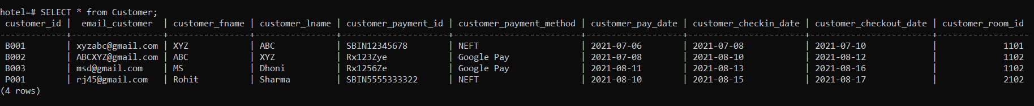

CREATE TABLE Today_Price(

t_h_id int,

foreign key(t_h_id) references Hotel(hotel_id),

room_t_p_id int,

foreign key(room_t_p_id) references Rooms(room_id),

price decimal(10,2) NOT NULL,

availability char NOT NULL,

today_date date NOT NULL,

primary key(today_date,room_t_p_id)

);

CREATE TABLE Reservation(

r_room_t_p_id int,

r_date date,

r_c_id varchar(10),

primary key(r_room_t_p_id,r_date,r_c_id),

start_date date NOT NULL,

end_date date NOT NULL

);

CREATE Table Invoice(

invoice_id varchar(10),

i_c_id varchar(10),

primary key(invoice_id,i_c_id),

foreign key(i_c_id) references Customer(customer_id),

i_fname varchar(30),

i_lname varchar(30),

amount decimal(10,2)

);

ALTER Table Invoice

ADD CONSTRAINT fk_ifname

FOREIGN KEY(i_fname)

References Customer(customer_Fname);

ALTER Table Invoice

ADD CONSTRAINT fk_ilname

FOREIGN KEY(i_lname)

References Customer(customer_Lname);

CREATE TABLE Customer_Contact(

customer_contact_id varchar(10),

contact_number bigint,

primary key(customer_contact_id,contact_number),

foreign key(customer_contact_id) references Customer(customer_id)

);

**Queries:**

1. Query to display employee names whose salary >45000;

1. SELECT contact_number from Customer_Contact AS C INNER JOIN Reservation ON Reservation.r_c_id=C.customer_contact_id WHERE c.customer_contact_id IN (SELECT r_c_id from Reservation WHERE Reservation.r_room_t_p_id='1102');

This query displays contact number of all customers who have reserved a room in hotel whose id is 1102.

1. Text

   Description automatically generatedQuery to display names of all employees who are located in bangalore.
2. Text

   Description automatically generatedQuery to display average salary of the employees who are located in Rajasthan.
3. 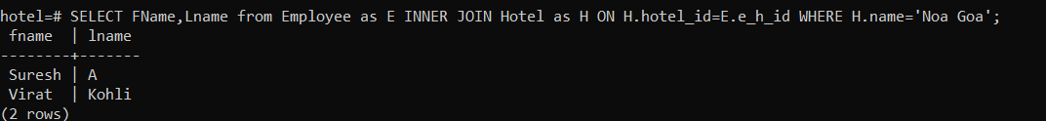Query to display name of employees who work in a hotel named Noa Goa.
4. This query displays names of all customers who has reserved an AC Room.

1. This query displays the contact number of the customer along with the amount they have paid

1. Display names of all employees whose salary is in the range of 30000 and 40000.

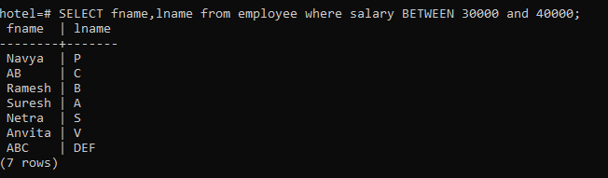

1. Query to display the employee table with the salaries sorted in descending order.

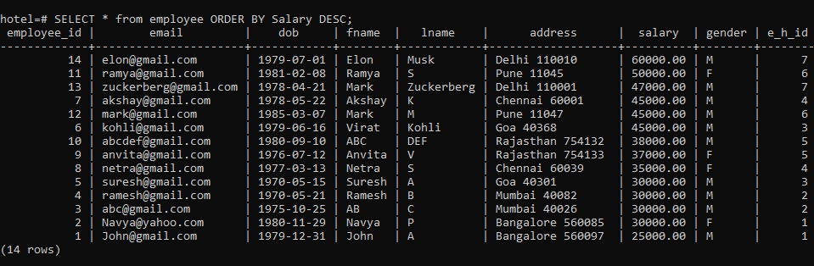

1. Query returns the number of AC and Non AC Rooms available from the list of all hotels.

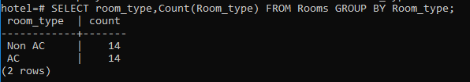

1. Query using Limit and Offset

